EXER - Creating a Simple Theme - Work on jupiter for this exercise

Log in to jupiter using winSCP or FileZilla or similar as follows:

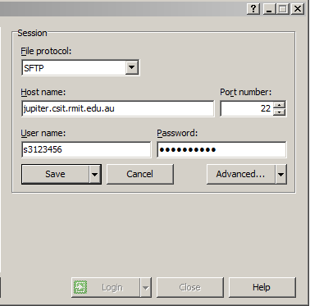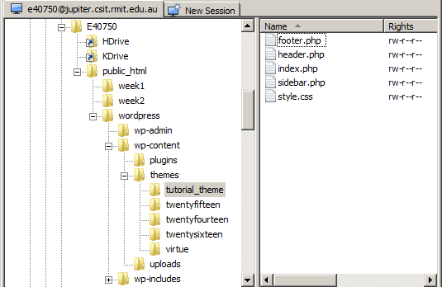
s3123456
s3123456

Open up the file called REF - How to Create a Simple WordPress Theme.pdf It is on Blackboard.
Don't go to the Siteground Website, as the code is now poorly indented and hard to understand.
Make sure that file extensions are being displayed on your laptop. Go to Folder Options.
Create a folder called tutorial_theme with 5 empty files inside it called:
header.php index.php sidebar.php footer.php style.css
Copy the five pieces of code (HTML, CSS and PHP) in the .pdf file into the five files and save them.
Look at the code in the index.php file. Note the lines that get the header, get the sidebar and get the footer, as well as the while loop.
A key to how Word Press works is called "The Loop". Can you explain it? Google this and read the PDF REF doc.
Place the tutorial_theme folder inside the themes folder in wordpress on jupiter.
Assign 0755 permissions to the folder recursively (to the 5 files inside the folder). This should be automatic.
Go to your Dashboard as follows: jupiter.csit.rmit.edu.au/~s3123456/wordpress/wp-admin
Go to Appearance | Themes and Activate the new theme which is currently called tutorial_theme. It does not have a screen shot.
Check your Web page. It should look something like this via jupiter.csit.rmit.edu.au/~s3123456/wordpress
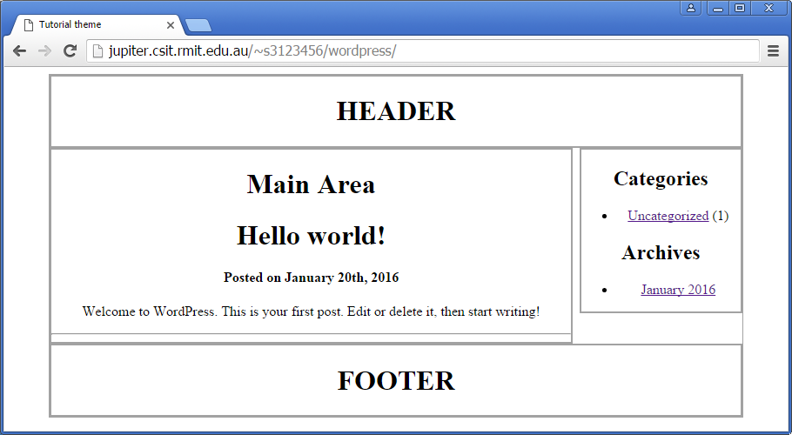
After you demonstrate the above to your teacher, please download, install and activate the Twenty Ten Theme.
EXER - Creating Your Own Plugins - Work on jupiter for this exercise
Next week we will write some very basic plugins, based on these very basic introductory tutorials. Please try at least one of these for homework:

Plugins to Add Words

http://hardcorewp.com/2012/how-to-write-a-basic-wordpress-plugin/ Very simple, but explains both types of 'hooks' (ie. 'actions' & 'filters') - Adds "Thanks for Reading" at the end of posts

OR

http://corpocrat.com/2009/12/27/tutorial-how-to-write-a-wordpress-plugin/ Simple & develops concepts via a 'Hello world' plugin: Maybe the best simple tute. Similar to the 'Thanks for Reading' plugin

Plugins to Convert Words

https://markjaquith.wordpress.com/2006/03/04/wp-tutorial-your-first-wp-plugin/ Video for a plugin which changes "foo" to "bar" - a really great video, but it uses a very, very old version of WP. Similar to Catify

OR

http://www.htmlgoodies.com/beyond/webmaster/projects/article.php/3877226/WordPress-For-the-Web-Developer-How-To-Write-Your-Own-Plugins.htm Simple plugin called Catify which changes "dog" to "cat"

Plugin to Create a Form

http://www.sitepoint.com/build-your-own-wordpress-contact-form-plugin-in-5-minutes/ Simple, even useful. This plugin does not contain any 'hooks' however.

Note on 'hooks'

In WordPress there are two types of 'hooks', called 'actions' and 'filters'. WordPress has over 2000 different types of hooks. The PHP coding within WordPress is quite advanced.

WordPress hooks allow your plugin to 'hook into' the rest of WordPress ie. to call functions in your plugin at specific times. This sets your plugin in motion.

Try this resource: http://blog.teamtreehouse.com/hooks-wordpress-actions-filters-examples

We will not be aiming to become plugin developers in this course. However you can certainly begin to experiment.

